**Advice of Changes**

**Which of the following do you wish us to change ? ….**

Is there to be a change in their **rate of Pay** ? … … … … … … … … … … … … … … go to box 1.

If the Stipend changes, go straight on and fill in box 11, Pensionable Income and monthly amounts.

Is there a **change in the ordinary hours this person works** ? … … go to box 2.

… or **the days of the week** ? … go to box 3.

If Stipend is changing, is the payment for **use of private home** so is Manse to be changed as well ?

Please restate Current housing allowance paid whether or not it’s changed … … … go to box 4.

 **If you have a change of Tax Code or Student loan Repayment, just send us a copy of the HMRC letter.**

Is there a change in an employee’s **expenses or other non-salaried amount** ? … … … … … go to box 5.

Examples of Taxable expenses are Heat & Light, Cost of Living

Examples of Non-taxables might be Telecoms, Mileage and stationery

Heat & Light **may have a non-tax element** if say 25% is for church usage of manse

Has the member of staff worked **Specific hours this month**? Are there any **Holiday** **Hours or a Bonus** to be paid ?

… … go to box 6.

Has this member of staff worked **Overtime hours at Premium Rate(s)**  … … … go to box 7.

Are you making deductions from an employee for **CycleToWork, Child Care Vouchers**

or any other Salary Sacrifice scheme ? … … … … … … … … … … … … … … go to box 8.

Do you need to make any other **deduction**s, e.g. for rental, advance or Earnings Attachments ?... go to box 9.

Do you need to record any **absences** from work ? … … … … … … … … … … … … … go to box 10.

Are they or you **starting, or adjusting** the amount of, a **Pension contribution** ? … … … … … go to box 11.

Has your employee changed their Name, Address, Marital status ? Have they got a n**ew Bank**

Account, or a new Name for their account ? … … … … … … … … … … go to box 12.

Is your member of staff **Leaving** your employ: please state last day employed?

Are there any **Holidays** dueor payment in lieu ? … … … … … … … go to box 13.



|  |
| --- |
| Church or Organisation* |
|  |
| Employee name * |
|  |

**Advice of Changes**

|  |
| --- |
|  |

To be on Payroll for (Month of) …

|  |
| --- |
|  |

|  |
| --- |
|  |

1. **Rates of Pay: New Annual Stipend** £ ** **Or **New Hourly rate** £

|  |
| --- |
|  |

**Effective date of change**: **We will adjust to back date a change**

|  |
| --- |
|  |

2. If Hourly, please always **state Hours normally Worked**

|  |
| --- |
| Sun M Tu W Th Fri Sat |
|  |

3. **Normal Days Worked** Circle the days of the week worked?

|  |
| --- |
| ** ** Now Go to Box 11 |

|  |
| --- |
|  |

4. **Housing (manse) payment**  £ per month

5. **Expenses**

|  |  |  |  |
| --- | --- | --- | --- |
| **Beginning Date** | **End Date** or Once-only or Until Further Notice (UFN) | **Amount for month £** | **Taxable / Non-taxable** – if both use separate line |
| Heat & Light |  |  |  |  |
|  |  |  |  |  |
|  |  |  |  |  |

|  |  |
| --- | --- |
|  | |
| **At £** |  |

|  |  |  |
| --- | --- | --- |
|  | **£** |  |

6. **Ordinary Hours**  **Holiday or Bonus**

|  |  |  |
| --- | --- | --- |
|  | **At £** |  |

|  |  |  |
| --- | --- | --- |
|  | **At £** |  |

7. **Overtime Hours** £ £

8. **Salary Sacrifice – are you starting to pay any of the following**:

|  |  |  |
| --- | --- | --- |
| **Beginning Date** | **Amount per month £** | **Date ceased** |
| CycleToWork scheme |  |  |  |
| Childcare Vouchers |  |  |  |
|  |  |  |  |

1. **Deductions – please specify**:

|  |  |  |
| --- | --- | --- |
| **Details** | **Beginning - Until** | **Amount per month £** |
| Rental |  |  |  |
|  |  |  |  |
| Advance of Pay |  |  |  |
| Attachments of Earnings |  |  |  |
|  |  |  |  |

1. **Absences – please specify  **:

|  |  |  |  |  |
| --- | --- | --- | --- | --- |
| **Type – e.g. Sickness, or Maternity** | | **Date first Absent from work** | **Date returned to work** | **Pay Basic salary, or just SSP, etc.** |
| Sickness etc. |  | |  |  |  |
| Maternity |  | |  |  |  |
| ** Please attach copy of fit note/ MatB1/SC3/SHPP form** | | | |

1. **Pension Contributions (box 1)  Enter Pension amount *whenever* Stipend changes**

|  |  |  |  |  |  |  |
| --- | --- | --- | --- | --- | --- | --- |
| **Pension company details** |  | | | | | |
| **Contributions based on Pensionable Income (PI) ( *full* e.g. BPS), or only on earnings over £520 (some NEST) (known as *Qualifying Earnings*) £ amt** | | | | | **e.g.stipend+manse+….... = ………………...........** | |
| **Contribution Type** | **Employee** | **AVC (‘ee)** | **Employer** | **AVC (‘er)** | | **Notes** |
| NEST etc Contribution **%rate** |  |  |  |  | | **Probably based on Salary less £520:4%, 3%** |
| Baptist Pension(BPS) /Private Contribution **monthly** **£ amt** |  |  |  |  | | **Employer=Sum of 2 figures in 4mystaff** |

1. **Personal Details Changes**

|  |  |  |  |
| --- | --- | --- | --- |
| Current Name |  | **New Email address** |  |
| **Change name to** |  | **Nat Ins No** |  |
| **Change of address** |  | **New Marital status** |  |
|  |  | **Bank Details** | |
|  | A/c Name |  |
|  | Sort code |  |
|  | A/c Number |  |
|  |  |  |

|  |  |  |  |  |  |  |  |  |  |  |  |  |
| --- | --- | --- | --- | --- | --- | --- | --- | --- | --- | --- | --- | --- |
| 1. **Employment termination**  |  |  |  |  |  | | --- | --- | --- | --- | --- | | **Leaving ?** | **Date of leaving** |  | **Holiday payable** |  |  |  | | --- | | **Comments.** Please tell us here about **anything** else that we mightneed to know**.** | |  | | |  |  |  |  |
| Secure Word Doc with your **Password**\*  **See note over the page** | |
| Please print **your name** * |  |  |
| Date * |  |

**Notes – and see overleaf * Starred fields must be actioned or entered**

**To Save a Word document**

First click on the File Menu (top left)

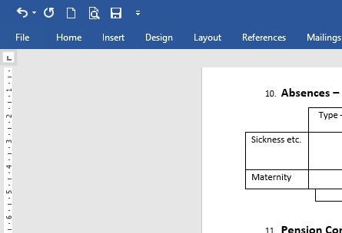

Make sure you are in the Info Area

Next Click on the “Protect Document” grey square icon

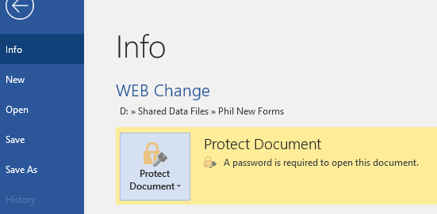

Then select ‘Encrypt With Password’ from the menu that drops down. Its icon appears as a padlock and key.

You will then be given two requests to put a password in. Make sure it exactly matches the **Password that you created on your Accounts Access Authorisation** form. It must be the same case and have no spaces. The document will only open when we use the password you have sent us.

**To return and make further changes** or merely to Save, click on the ‘Back Arrow’ top left.

**Email** this to us – thanks!